Batch: B2 Roll No.: 16010121200
Experiment No.: 03
Grade: AA / AB / BB / BC / CC / CD /DD

Signature of the Staff In-charge with date

Title: Study and implementation of Perceptron learning rule.
____________________________________________________________________________________
Objective: To write a program to implement Logic gates problem using perceptron network training
____________________________________________________________________________________
Expected Outcome of Experiment:

CO2: Analyze various training algorithms of neural network and its architectures
____________________________________________________________________________________
Books/ Journals/ Websites referred:

__________________________________________________________________________________
Pre Lab/ Prior Concepts:

- Learning
- Types of learning
- Perceptron learning rule.

Steps of Perceptron learning algorithm/approach for binary classification
- Feed the features of the model that is required to be trained as input in the first layer.
- All weights and inputs will be multiplied – the multiplied result of each weight and input will be added up
- The Bias value will be added to shift the output function
- This value will be presented to the activation function (the type of activation function will depend on the need)
- The value received after the last step is the output value.

Single layer perceptron network for each logic functions

Implementation Details:

Implement AND, OR, NOR, NAND logic function (bipolar inputs and bipolar targets) using perceptron training algorithm.
(Show the output of each epoch)

Activation function used (threshold activation):
# Activation function

def activation(net, threshold):
if net >= threshold:
return 1
else:
return -1

Perceptron Training Algorithm:
# Perceptron Training Algorithm

def perceptron(input_vector):

# Initial setup
threshold = random.randrange(0,5)
w1 = random.randrange(-2,3)
w2 = random.randrange(-2,3)
wb = random.randrange(-2,3)
print("Threshold = {0}\n".format(threshold))
print("Initial weights:\nw1 = {0}\tw2 = {1}\twb = {2}\n".format(w1, w2, wb))

# Algorithm
repeat = True
result = [0, 0, 0, 0]
j = 0
while repeat:
j += 1
print("Iteration {0}".format(j))
i = 0
for input in input_vector:
x1, x2 = input
t = target[i]
net = x1*w1 + x2*w2 + wb
y = activation(net, threshold)
result[i] = y
if y != t:
w1 = w1 + (t-y) * x1
w2 = w2 + (t-y) * x2
wb = wb + (t-y)
i += 1
print("Weights after input ({0}, {1}):\tw1 = {2}\tw2 = {3}\twb = {4}".format(x1, x2, w1, w2, wb))
print("Iteration complete.")
print("Updated weights:\nw1 = {1}\tw2 = {1}\twb = {3}\n".format(j, w1, w2, wb))
if result == target:
repeat = False
print("Final weights:\nw1 = {0}\tw2 = {1}\twb = {2}\n".format(w1, w2, wb))
return result
Function for displaying logic table:
def displayLogic(input_vector, target, result):
column_names = pd.DataFrame([["Input Vector", "x1"],
["Input Vector", "x2"],
["Target", "Output"],
["Predicted", "Output"]],
columns=["", ""])

rows = []
for i, input in enumerate(input_vector):
x1, x2 = input
row = []
row.extend([x1, x2, target[i], result[i]])
rows.append(row)

columns = pd.MultiIndex.from_frame(column_names)

df = pd.DataFrame(rows, columns=columns)
df = df.style.set_properties(**{'text-align': 'right'})
display(df)
return

AND logic function:
# AND Gate
x_1 = [-1, -1, 1, 1]
x_2 = [-1, 1, -1, 1]
input_vector = list(zip(x_1, x_2))
target = [-1, -1, -1, 1]

result = perceptron(input_vector)
displayLogic(input_vector, target, result)
Output:
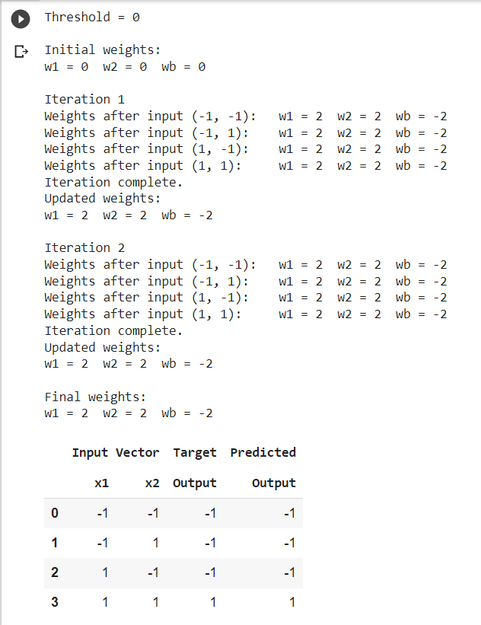
OR logic function:
# OR Gate
x_1 = [-1, -1, 1, 1]
x_2 = [-1, 1, -1, 1]
input_vector = list(zip(x_1, x_2))
target = [-1, 1, 1, 1]

result = perceptron(input_vector)
displayLogic(input_vector, target, result)
Output:
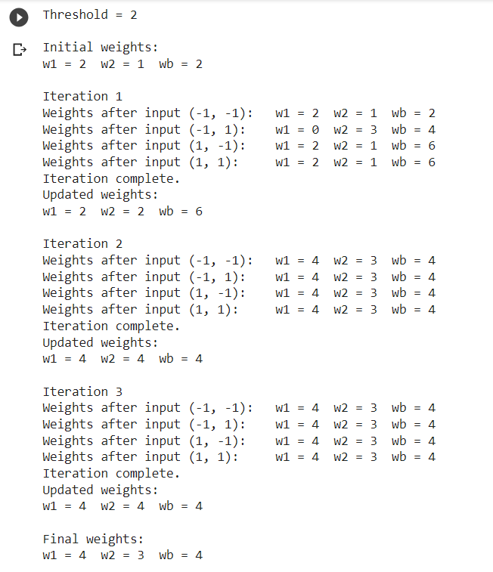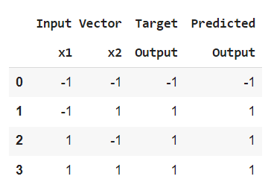

NOR logic function:
# NOR Gate
x_1 = [-1, -1, 1, 1]
x_2 = [-1, 1, -1, 1]
input_vector = list(zip(x_1, x_2))
target = [1, -1, -1, -1]

result = perceptron(input_vector)
displayLogic(input_vector, target, result)
Output:
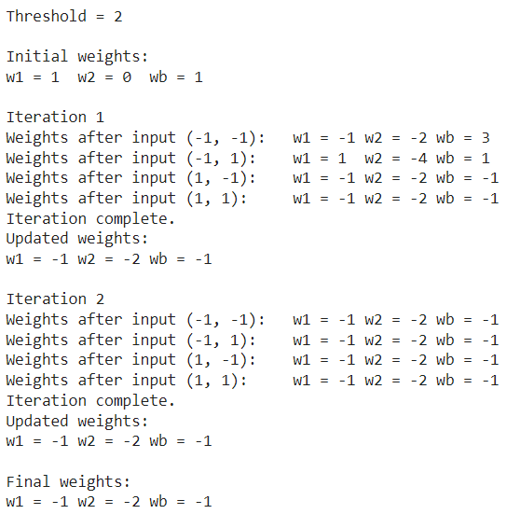
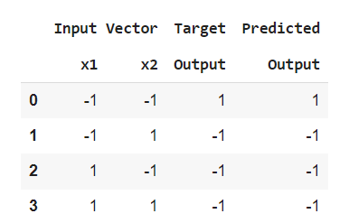

NAND logic function:
# NAND Gate
x_1 = [-1, -1, 1, 1]
x_2 = [-1, 1, -1, 1]
input_vector = list(zip(x_1, x_2))
target = [1, 1, 1, -1]

result = perceptron(input_vector)
displayLogic(input_vector, target, result)
Output:
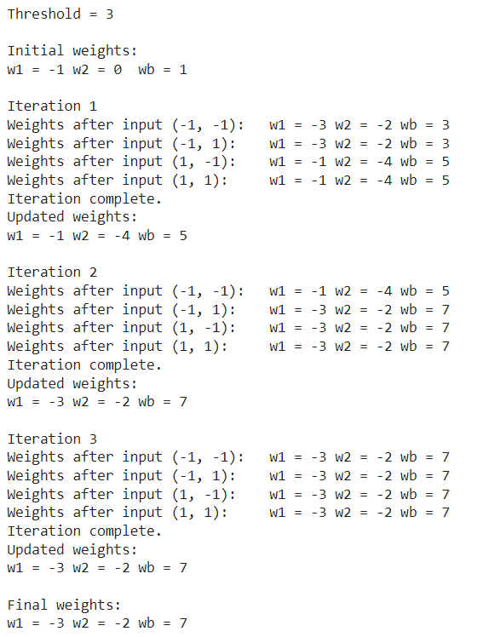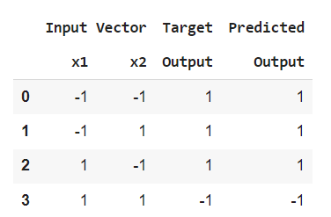

Conclusion:
Thus, we have successfully implemented perceptron training algorithm for AND, OR, NOR and NAND functions.

Post Lab Descriptive Questions:

- How is linear separability implemented using perceptron networking training.
A single perceptron consists of inputs, weights, bias, and an activation function to serve the output. Assume the output of the perceptron to be y, and let x be an input to the perceptron with a single input, then y = w1*x + b, where w1 is the weight for the input, and b is the bias.
Simplify this problem by assuming w1 to be 1, and b to be 0.This makes the equation to be y = x, which is the equation of the straight line passing through the origin.

- Mention the application of perceptron network.
The Perceptron plays an essential role in Machine Learning projects. It is massively
used to classify data, or as an algorithm to simplify or supervise the learning
capabilities of binary classifiers

.

Date: 16/08/2023 Signature of faculty in-charge

